Case 2-A259-Afr-Egy-Ushabti-Ptolemaic Dynasty-Hieroglyphs-Isis Pectoral-Blue Faience

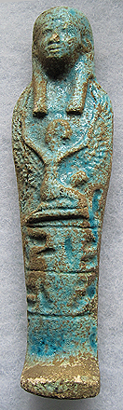 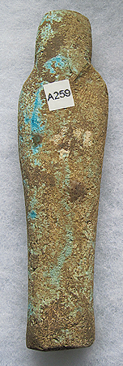

Figs. 1-2. Ushabti-Ptolemaic Dynasty-Hieroglyphs-Winged Scarab Pectoral-Blue Faience

**Case No.: 2**

**Formal Label:** Ushabti-Ptolemaic Dynasty-Hieroglyphs-Winged Scarab Pectoral-Blue Faience

**Display Description:** This mummiform Ushabti wears a plain lappet wig with a single horizontal band and Isis as a pectoral guardian.

The location of this Ushabti may have been from the cult center of the Sun, *I͗wnw* ( "The Pillars") or in its well-known Greek name *Hēlioúpolis* / Heliopolis (Ἡλιούπολις), meaning “City of the Sun” of Khepri, Ra / Re, and Atum.

**Accession Number: A259**

**LC Classification:** DT64

**Date or Time Horizon:** 305-30 BCE

**Geographical Area: Old Cairo, Egypt**

**Map, GPS Coordinates:** 30.12933 31.30753; 40° 26' 46" N 79° 58' 56" W

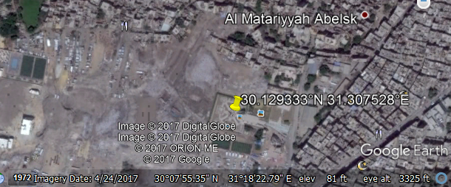

**Cultural Affiliation:** Ptolemaic Dynasty

**Medium:** Blue faience

**Dimensions: 139.52 mm; 5.49 in**

**Weight: 82 gm; 2 7/8 oz**

**Provenance: Old European Collection**

**Condition:** Original

**Discussion:** Ushabtis are anthropomorphic figurines representing servants of the élite deceased in the Hereafter and were placed with them in their internments. The Amduat [underworld] included irrigated tracts of land that were mythically granted to the deceased by the Sun God, Ra, which the Ushabti servant workers would act as agricultural workers in the fields or as fishermen or in many other labor intensive tasks. Nobles and royalty felt that the more Ushabtis they were interred with they would be spared manual labor in the Hereafter. Thus, what began as grave sites as having fewer and larger sized Ushabtis gradually expanded into large proliferations of smaller Ushabtis, as patrons sought to out-do their neighbors. Hieroglyphs usually alluded to the opening phrases of Chapter 6 of the *Book of the Dead*: “Greetings Ushabti. If Osiris [the deceased’s name inserted] be decreed to do any work in Khert-Neter [hereafter], let any impediment be removed. Here I am [to do the work for him].”

**References:**

Aubert, J.-F. et L. Aubert. 1974. *Statuettes Egyptiennes: Chaouabtis, Ouchebtis.* Paris, 1974.

Janes, Glenn. 2002. *Shabtis. A Private View, Ancient Egyptian Funerary Statuettes in European Private Collections.* Paris: Cybèle.

Newberry, Percy E. 1930-1957. *Funerary Statuettes and Model Sarcophagi.*  Le Caire: Impr. de l'Institut français d'archéologie orientale.

Schneider, Hans D. 1977. *Shabtis - An Introduction to the History of Ancient Egyptian Funerary Statuettes. With a Catalogue of the Collection of Shabtis in the National Museum of Leiden*. 3 volumes. Leiden: Rijksmuseum van Oudheden Te Leiden.

Schlögl, Hermann and Andreas Brodbeck. 1990. *Ägyptische Totenfiguren aus öffentlichen und privaten Sammlungen der Schweiz.* Orbis Biblicus et Orientalis, Series Archeologica, 7. Göttingen, Vandenhoeck & Ruprecht; Freiburg Schweiz, Universitätsverlag.